Taylor Larrechea

Dr. Gustafson

Math 362 Fourier Analysis

November 4, 2017

Ch. 5.1

Section 5.1

5.1.3

For the expansion matrices given, use the matrix inner product to do the following. Show all work.

1. Show that $G_{00}, G_{01}, G_{10}, G_{11}$ are orthogonal to each other.
2. Determine the values of $\{G_{00},G_{00}\},\{G_{10},G_{10}\},\{G_{01},G_{01}\},\{G_{11},G_{11}\}$

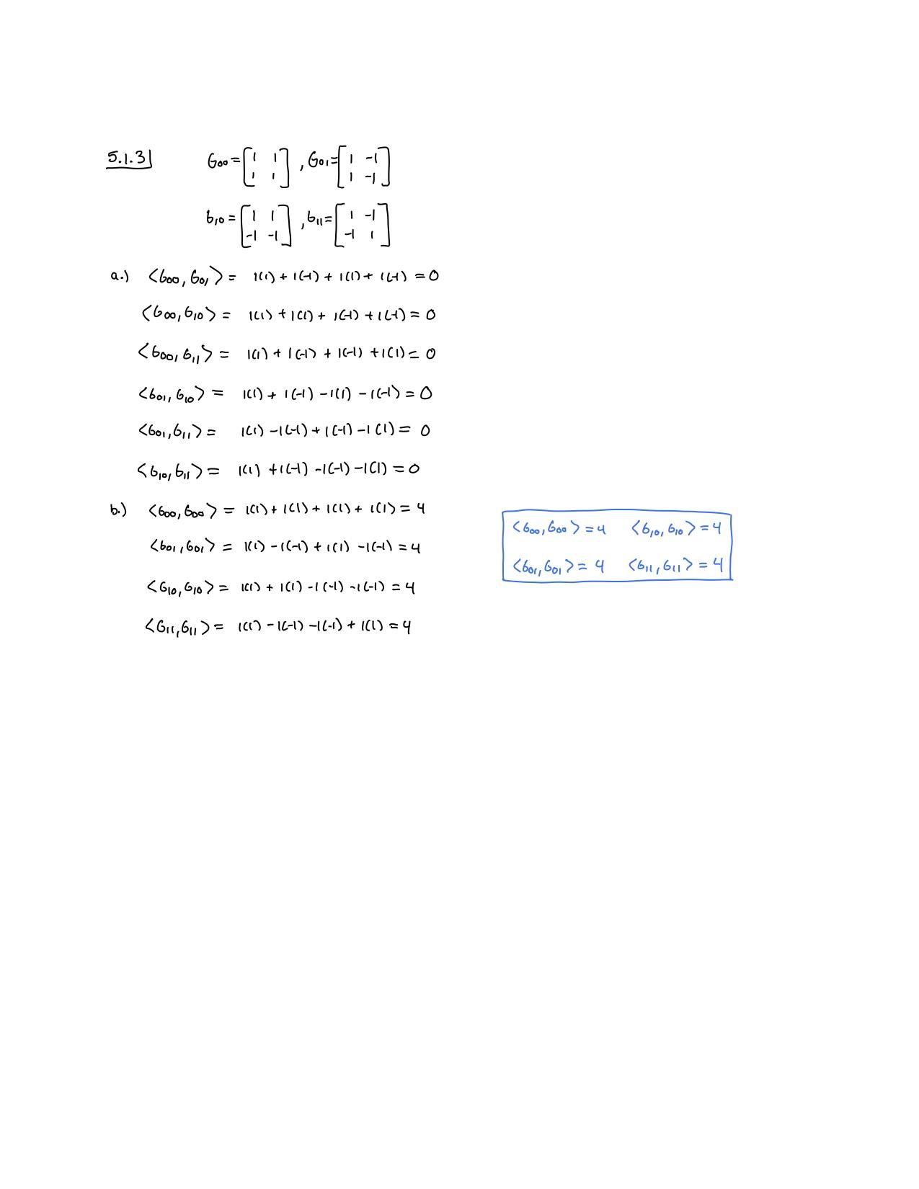

5.1.5

For the matrix given, use the expansion matrices given in Exercise 2 to do the following. Show all work and MATLAB commands.

(b) Find the transform matrix $D$ of $A$ using the m-file TransformMatrixD to compute $d_{mn}$ as in the second part of Example 5.1.3.

(c) Express $A$ as an expansion of $G_{00},G_{01},G_{10},G_{11}.$

b.)

|  |  |
| --- | --- |
| Input Commands | Output (Plot if Applicable) |
| >> A=[2,4;6,8];  >> G00=[2,0;1,0];  >> G01=[1,0;-2,0];  >> G10=[0,2;0,1];  >> G11=[0,1;0,-2];  >> TransformMatrixD(A,G00,G01,G10,G11) | D =  2.0000 -2.0000  3.2000 -2.4000 |

c.)

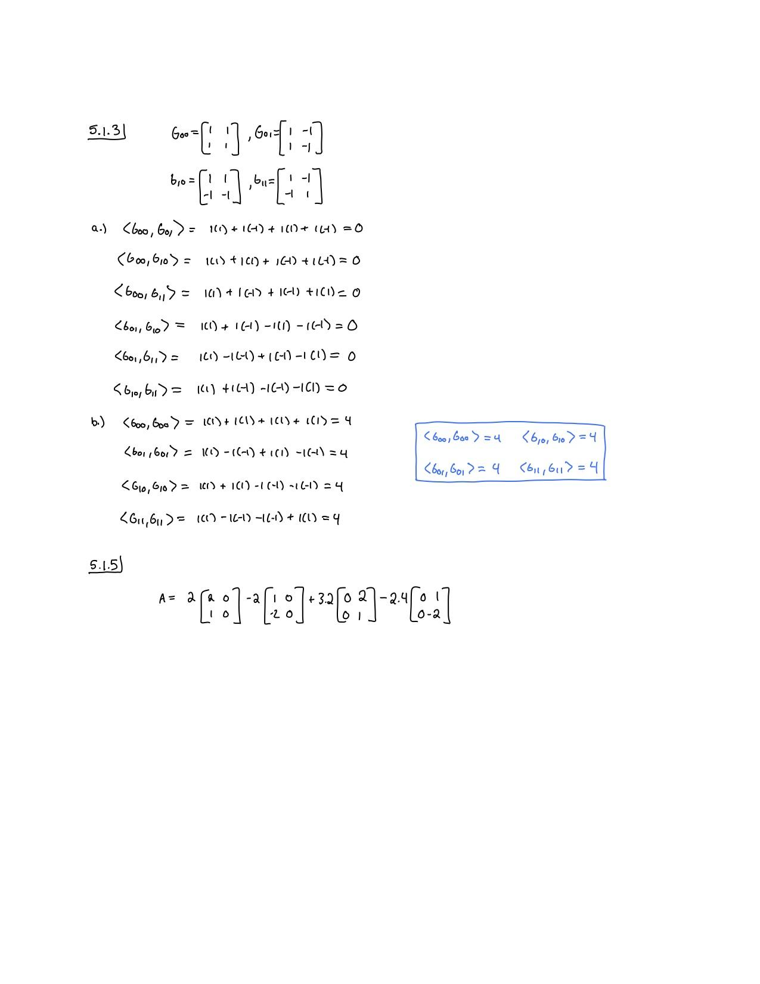

5.1.14

For the matrices $A$ given in the following exercise, do the following. Show all MATLAB commands used.

1. Find the 2D DFT of $A$ using the command fft2(A), as in Example 5.1.5.
2. Express $A$ as an expansion of $G_{00},G_{01},G_{10},G_{11},$ using the Fourier expansion matrices given in Exercise 3.

a.)

|  |  |
| --- | --- |
| Input Commands | Output (Plot if Applicable) |
| >> A=[2,4;6,8];  >> D=(1/4)*fft2(A) | D =  5 -1  -2 0 |

b.)